<参考答案见视频源码下载>

1、编写一个函数，能够实现任意3个数（DWORD）的加法，参数采用堆栈的方式进行传递，并将结果存储在EAX中。

2、调用上面的函数。

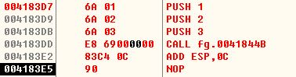

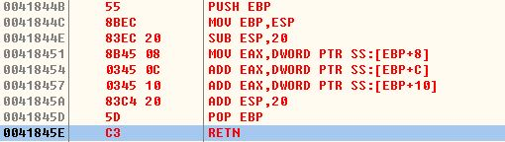

3、画出函数执行时堆栈的变化(从参数压栈开始画 一行指令对应一个堆栈图)。

|  |  |  |  |  |  |  |  |
| --- | --- | --- | --- | --- | --- | --- | --- |
|  |  |  |  |  |  |  |  |
|  |  |  |  |  |  |  |  |
|  |  |  |  |  |  |  |  |
|  |  |  |  |  |  |  |  |
|  |  |  |  |  |  |  |  |
|  |  |  |  |  |  |  |  |
|  |  |  |  |  |  | 004183E2 | esp:0018FF7C |
|  |  |  | push 3 | esp:0018FF80 | | push 3 |  |
|  |  |  | push 2 |  |  | push 2 |  |
|  |  |  | push 1 |  |  | push 1 |  |
|  | esp:0018FF8C | |  |  |  |  |  |
|  |  |  |  |  |  |  |  |
|  |  |  |  |  |  |  |  |
|  | ebp:0018FF94 | |  | ebp:0018FF94 | |  | ebp:0018FF94 |
| 调用前 |  |  | push |  |  | call |  |

|  |  |  |  |  |  |  |  |
| --- | --- | --- | --- | --- | --- | --- | --- |
|  |  |  |  |  |  |  | esp:0018FF58 |
|  |  |  |  |  |  |  |  |
|  |  |  |  |  |  |  |  |
|  |  |  |  |  |  |  |  |
|  |  |  |  |  |  |  |  |
| 0018FF94 | esp:0018FF78 | | 0018FF94 | ebp,esp:0018FF78 | | 0018FF94 | ebp:0018FF78 |
| 004183E2 |  |  | 004183E2 |  |  | 004183E2 |  |
| push 3 |  |  | push 3 |  |  | push 3 |  |
| push 2 |  |  | push 2 |  |  | push 2 |  |
| push 1 |  |  | push 1 |  |  | push 1 |  |
|  |  |  |  |  |  |  |  |
|  |  |  |  |  |  |  |  |
|  |  |  |  |  |  |  |  |
|  | ebp:0018FF94 | |  |  |  |  |  |
| push ebp |  |  | mov ebp,esp | |  | sub esp |  |

|  |  |  |  |  |  |  |  |
| --- | --- | --- | --- | --- | --- | --- | --- |
|  |  |  |  |  |  |  |  |
|  |  |  |  |  |  |  |  |
|  |  |  |  |  |  |  |  |
|  |  |  |  |  |  |  |  |
|  |  |  |  |  |  |  |  |
| 0018FF94 | ebp,esp:0018FF78 | |  |  |  |  |  |
| 004183E2 |  |  | 004183E2 | esp:0018FF7C | |  |  |
| push 3 |  |  | push 3 |  |  | push 3 | esp:0018FF80 |
| push 2 |  |  | push 2 |  |  | push 2 |  |
| push 1 |  |  | push 1 |  |  | push 1 |  |
|  |  |  |  |  |  |  |  |
|  |  |  |  |  |  |  |  |
|  |  |  |  |  |  |  |  |
|  |  |  |  | ebp:0018FF94 | |  | ebp:0018FF94 |
| add esp |  |  | pop ebp |  |  | retn |  |

|  |  |
| --- | --- |
|  |  |
|  |  |
|  |  |
|  |  |
|  |  |
|  |  |
|  |  |
|  |  |
|  |  |
|  |  |
|  | esp:0018FF8C |
|  |  |
|  |  |
|  | ebp:0018FF94 |
| add esp |  |